**QUESTION 1**

Please upload a Google Maps screenshot showing the location of your site in a broader context. In other words, they could be a pin on your site, but the map also shows a city or intersecting highways that show where in the world we are located.

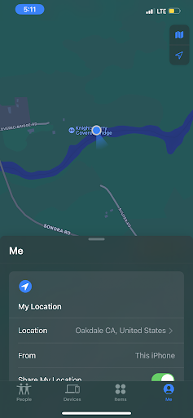

**1 points**

**QUESTION 2**

How do you get to your specific spot in the larger area. For example, how would you explain to a friend to meet you at your site, starting from, maybe, the parking lot.

**Once you leave the parking lot, you are going to follow the main pathway until you hit a big fallen tree on the left side. Once you see this tree, there is going to be a small hidden pathway on the right. That is the pathway you need to take to get to my site location. Once you take this pathway you are going to go down for a little until you hit a larger area with a rock in a middle of a circular path. My site location is near the river also, so once you hear water moving that’s when you know you are there.**

**2 points**

**QUESTION 3**

What are the latitude and longitude for your site?

If you did not capture a GPS coordinate during your visit, you can use this interactive map to click for the coordinate. Zoom in and use satellite view to make sure  you can really see your spot.    [https://www.gps-coordinates.net](https://www.gps-coordinates.net/)

Latitude: _____37.8196499_______

Longitude: ____-120.6721494___________

**1 points**

**QUESTION 4**

Provide your detailed description of the site. Include factors such as general terrain, topography, types of vegetation, site history (if there is something special about it that you know of).

The general terrain consists of hills, and riparian vegetations near the river. As I mentioned before, there is a river near my site. A lot of rocks surround my site, and the floor is covered with sand. There mostly dead or fallen plants and trees surrounding my area. There are some historical structures still present at this location beginning of the main path, such as Tulloch’s mill and bridge.

**3.5 points**

**QUESTION 5**

You sat quietly and attentively for at least 20 minutes. You looked around you for new details and living things. When your 20 minutes were up, you jotted down some notes about things you noticed.  Share those notes here by typing them in.

When I sat quietly for 20 minutes, I could hear the sounds of different birds calling and the subtle but calming sound of the river moving. As it is a popular location, I could also hear distant sounds of people laughing and chatting with each other.

**3 points**

**QUESTION 6**

After your quiet observation, you got active! You walked all around your site and made a master list of all the living things you found. It’s okay if you don’t know the official names of the plants, animals, and fungi you find. Just make sure you list them with a creative name that reminds you what they were. Type your master list in here.

|  |  |  |  |  |
| --- | --- | --- | --- | --- |
| **Kind of organism** | **My name for it** | **Size** | **Color** | **Other description** |
| Animal | Duck |  | Brown with yellow underneath |  |
| Animal | Bird |  | Mostly black with white underneath the beak | Medium length beak |
| Animal | Ant |  | Brown |  |
| Plant | Dandelion? |  | White | Looks dead and dried up |
|  |  |  |  |  |
|  |  |  |  |  |
|  |  |  |  |  |

**3 points**

**QUESTION 7**

Please upload Photo/Sketch 1 of your Site:

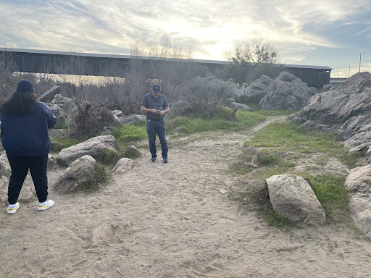

**1.5 points**

**QUESTION 8**

Please upload Photo/Sketch 2 of your Site:

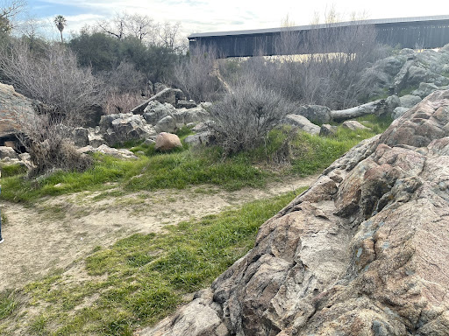

**1 points**

**QUESTION 9**

Please upload Photo/Sketch 3 of your Site:

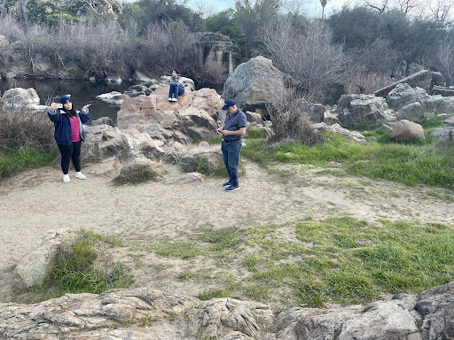

**1 points**

**QUESTION 10**

Please upload your Photo/Sketch of Living Thing 1:

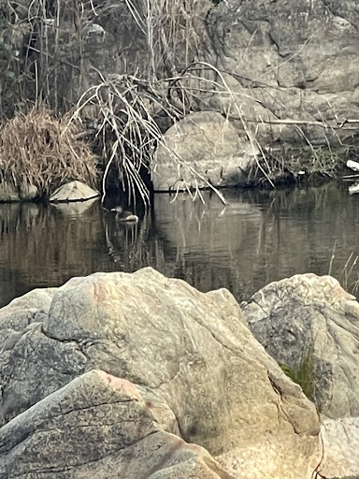

**1 points**

**QUESTION 11**

Please upload your Photo/Sketch of Living Thing 2:

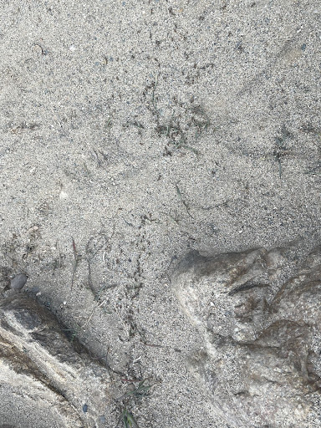

**1 points**

**QUESTION 12**

Please upload your Photo/Sketch of Living Thing 3:

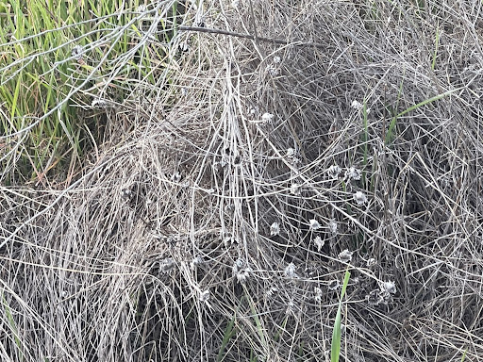

**1 points**

